**LIT TRAINING**

**Batch Name - SAP ABAP - 25                                                            DAY 12 ASSIGNMENT**

**EMPLOYEE ID – 46247689**

**Q-1. Demonstrate a case to Design the Adobe form to display the Flight Booking details.**

**Use Tables : SFLIGHT, SPFLI, SBOOK.**

**INTERFACE FOR ADOBE FORM**

**Dynamic text field importing:**

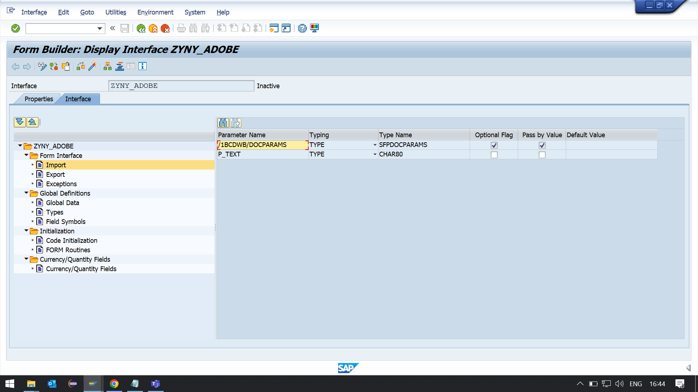

**DISPLAY LOGO ON FIRST PAGE**

**Logo Parameter AND internal table field inserted in Global data.**

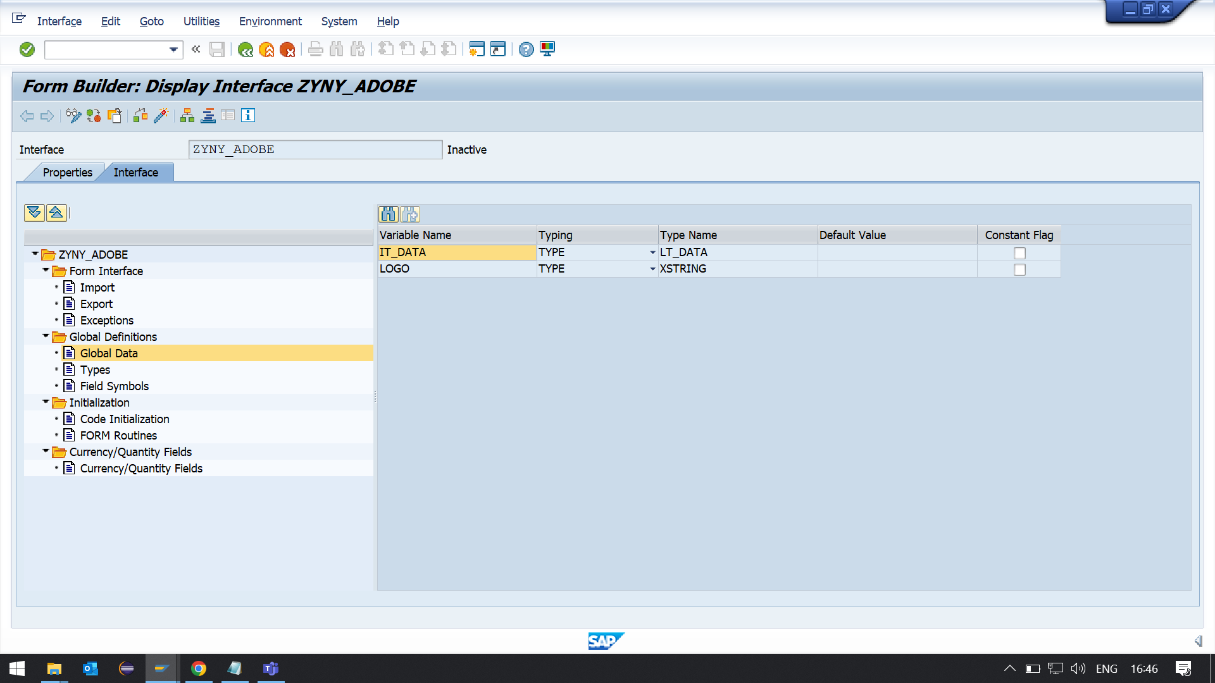

**Select Query:**

**SELECT A~carrid,  
        A~connid,  
        B~CITYFROM,  
        B~CITYTO,  
         C~BOOKID,  
         C~CLASS  
  FROM SFLIGHT AS A INNER JOIN SPFLI AS B ON A~CARRID = B~CARRID INNER JOIN SBOOK AS C  
                                                 ON B~CARRID = C~CARRID INTO TABLE @IT_DATA.**

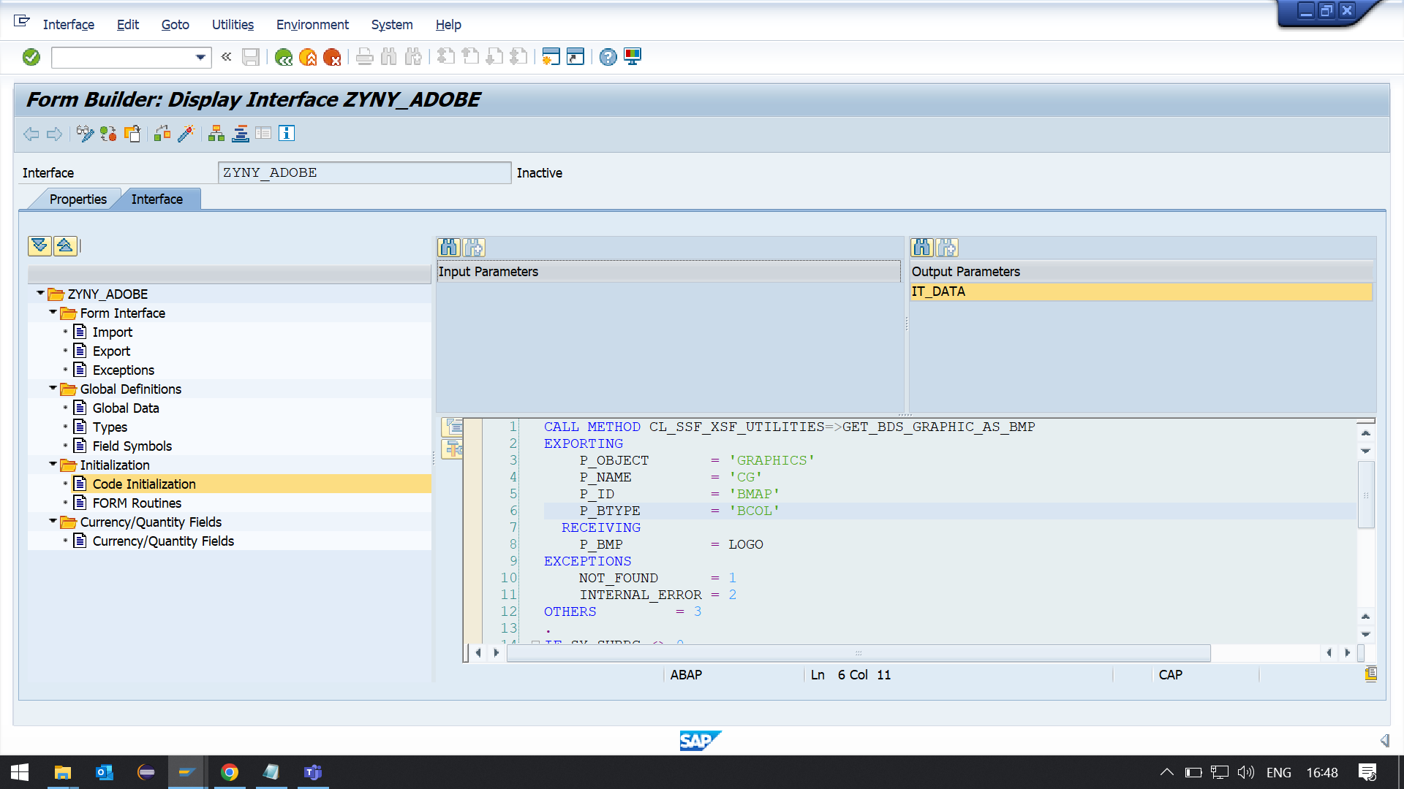

CALL METHOD CL_SSF_XSF_UTILITIES=>GET_BDS_GRAPHIC_AS_BMP  
EXPORTING  
    P_OBJECT       = 'GRAPHICS'  
    P_NAME         = 'CG'  
    P_ID           = 'BMAP'  
    P_BTYPE        = 'BCOL'  
  RECEIVING  
    P_BMP          = LOGO  
EXCEPTIONS  
    NOT_FOUND      = 1  
    INTERNAL_ERROR = 2  
OTHERS         = 3  
.  
IF SY-SUBRC <> 0.  
*\* Implement suitable error handling here*  
ENDIF.  
  
SELECT A~carrid,  
        A~connid,  
        B~CITYFROM,  
        B~CITYTO,  
         C~BOOKID,  
         C~CLASS  
  FROM SFLIGHT AS A INNER JOIN SPFLI AS B ON A~CARRID = B~CARRID INNER JOIN SBOOK AS C ON B~CARRID = C~CARRID INTO TABLE @IT_DATA up to 10 rows.

**ADOBEFORMS:**

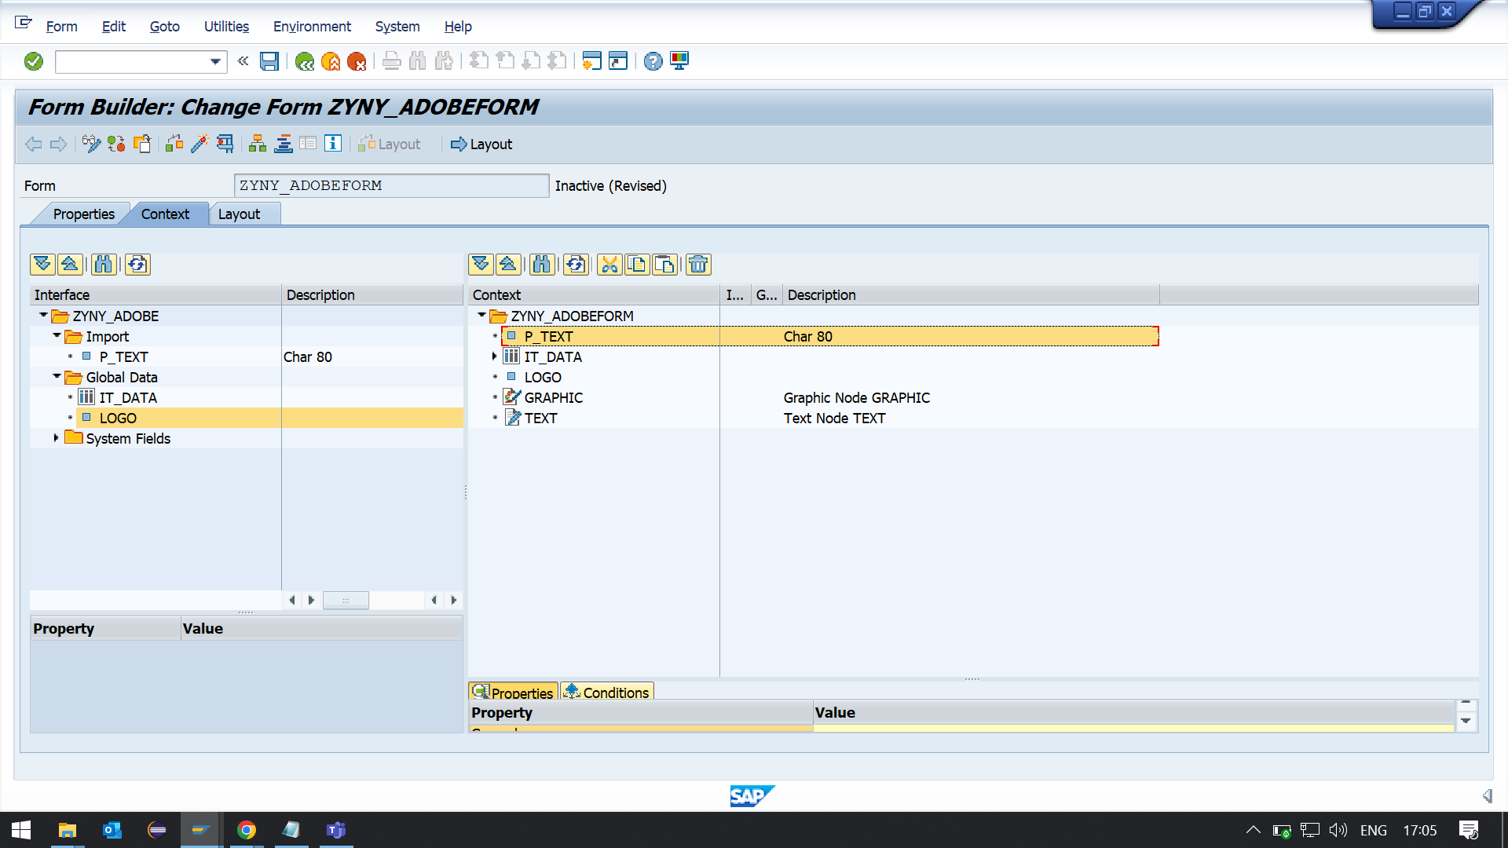

**LAYOUT:**

**Q-2. Demonstrate a case to use JavaScript in adobe forms and display Footer only on Last page.**

**footer**

**var curp = $layout.page ( ref ( $ ) )**

**var totalp = $layout.pageCount()**

**if ( curp ne totalp ) then**

**$.presence = "hidden"**

**endif**

**Q-3. Create a case to use JavaScript in adobe forms and display Logo only on first page.**

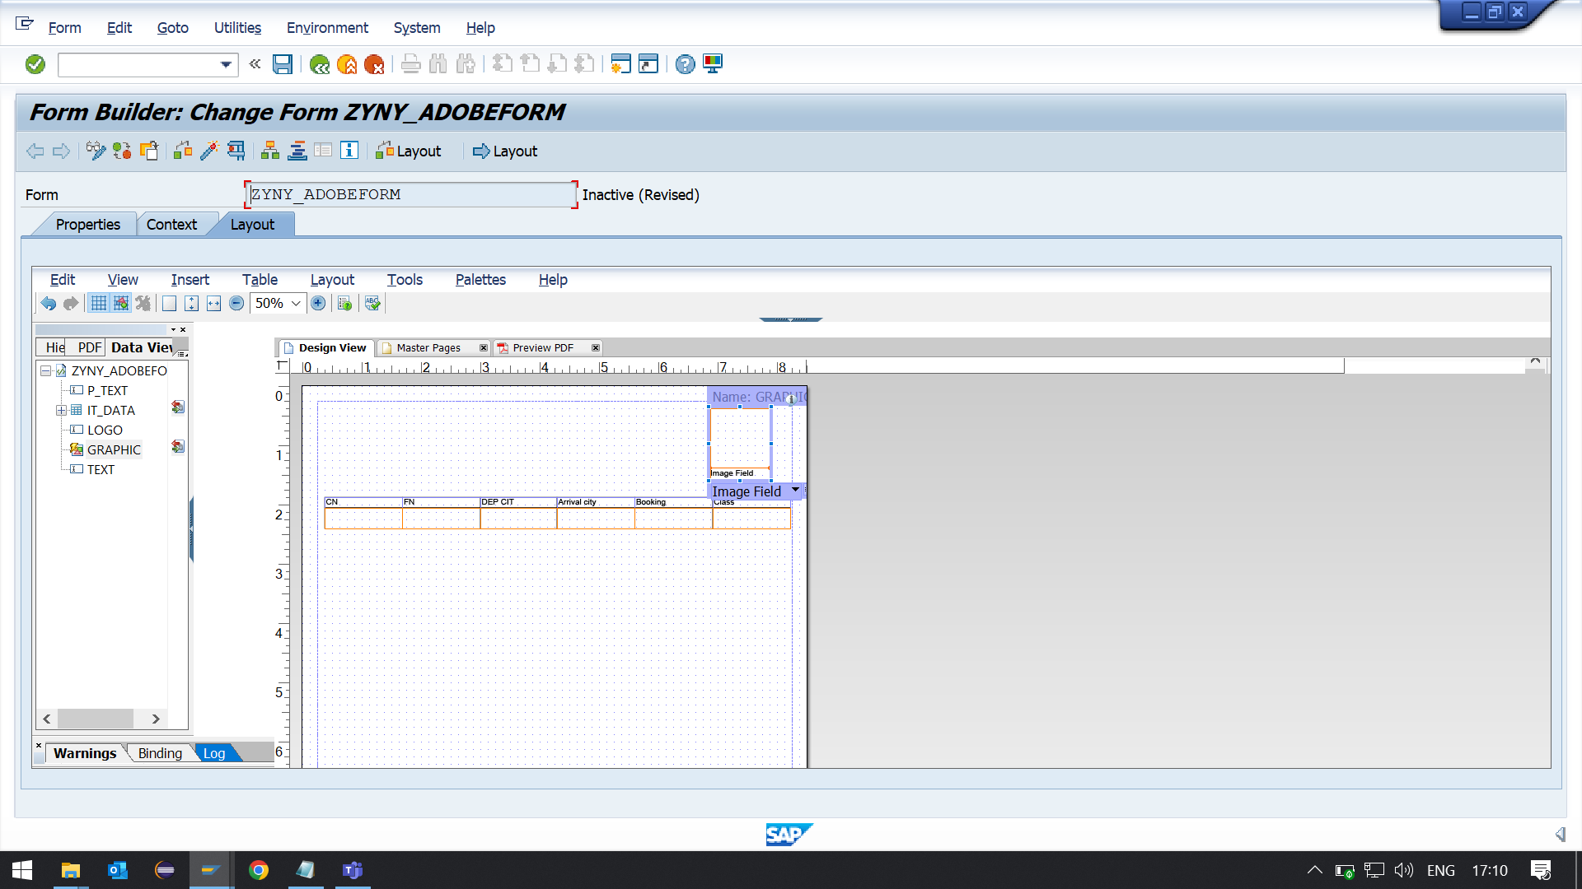

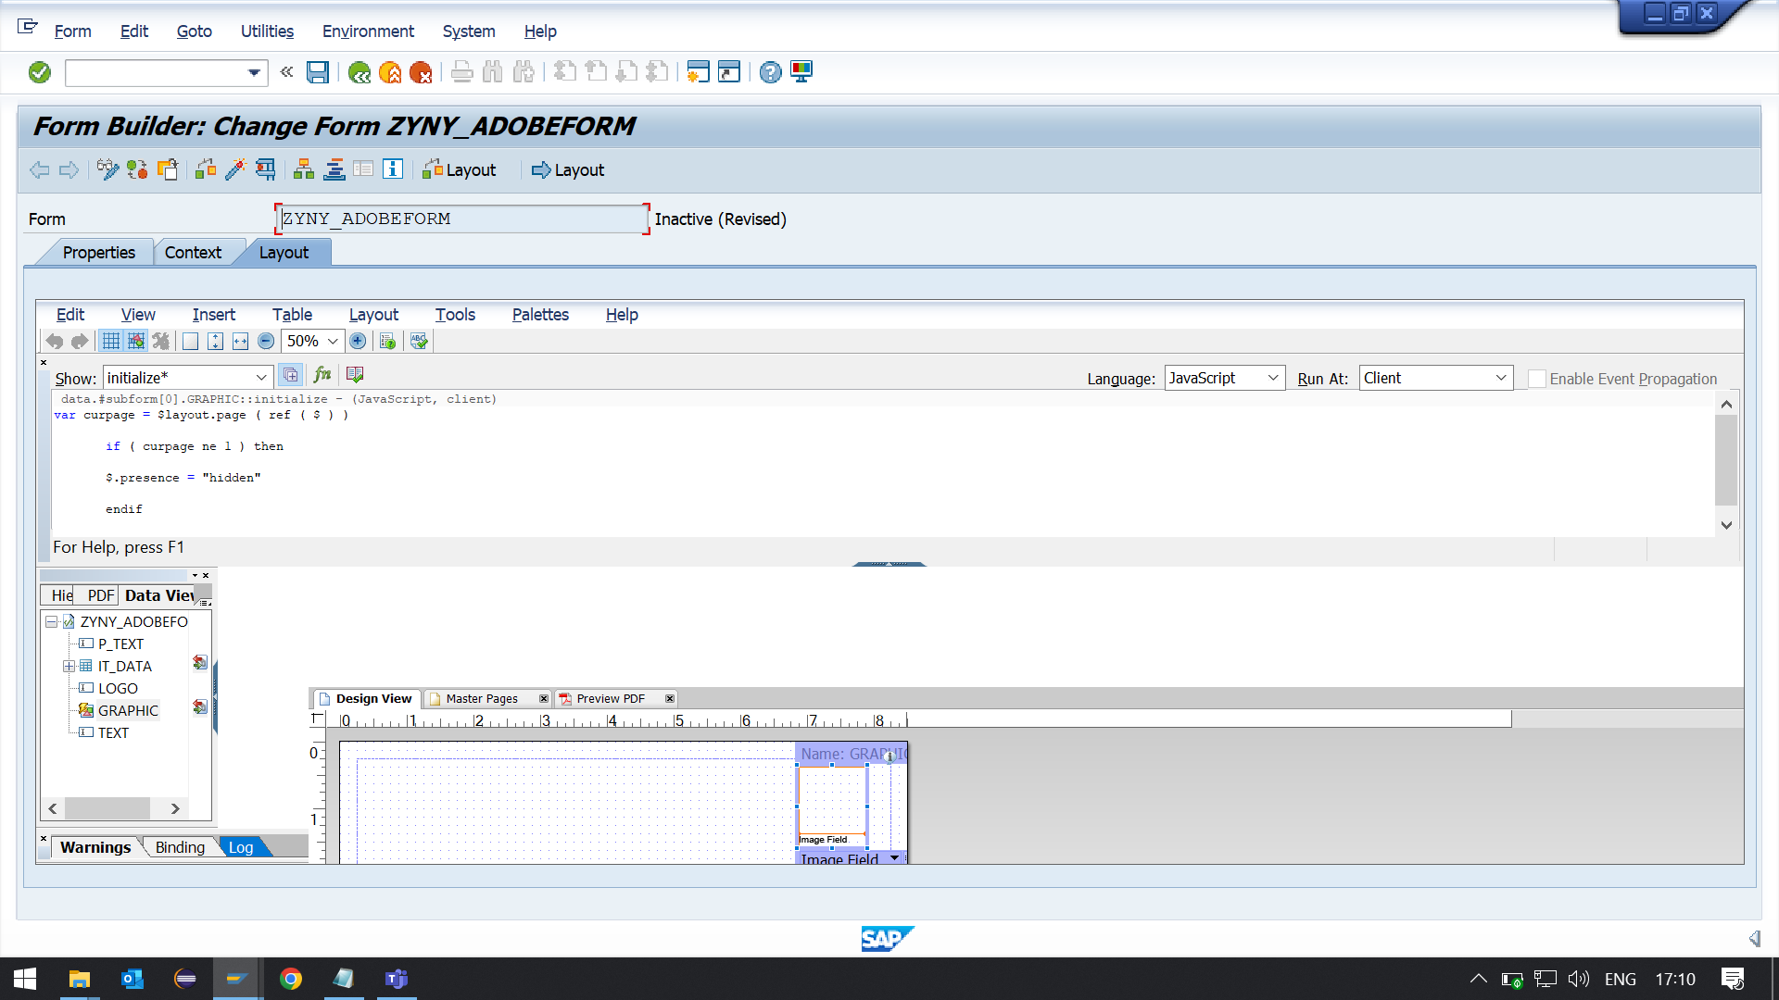

**logo**

data.#subform[0].GRAPHIC::initialize - (JavaScript, client)

var curpage = $layout.page ( ref ( $ ) )

if ( curpage ne 1 ) then

$.presence = "hidden"

endif

**footer**

**var curp = $layout.page ( ref ( $ ) )**

**var totalp = $layout.pageCount()**

**if ( curp ne totalp ) then**

**$.presence = "hidden"**

**endif**

**Q-4. Demonstrate a case to use Dynamic TEXT in adobe forms.**

1. **Go to T code SFP. Create an interface and then create a form (For details ,please refer the previous demos)**
2. **In the interface, create a importing parameter of type TSFTEXT**

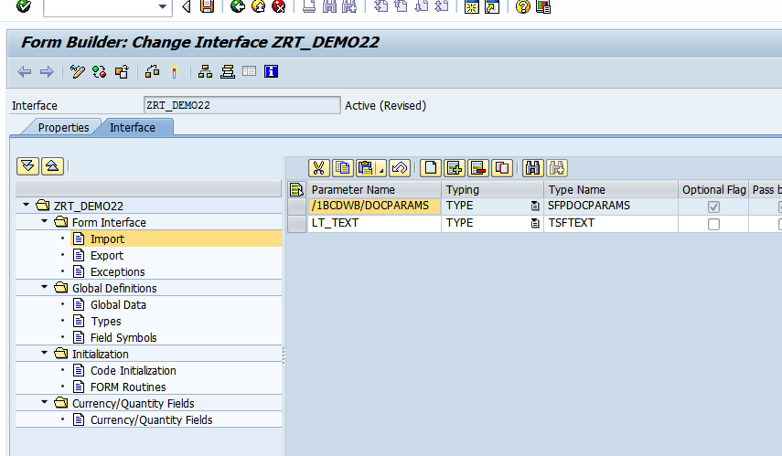

1. **Open the Form in SFP. Drag and drop the importing parameter LT_TEXT from Interface to context.**

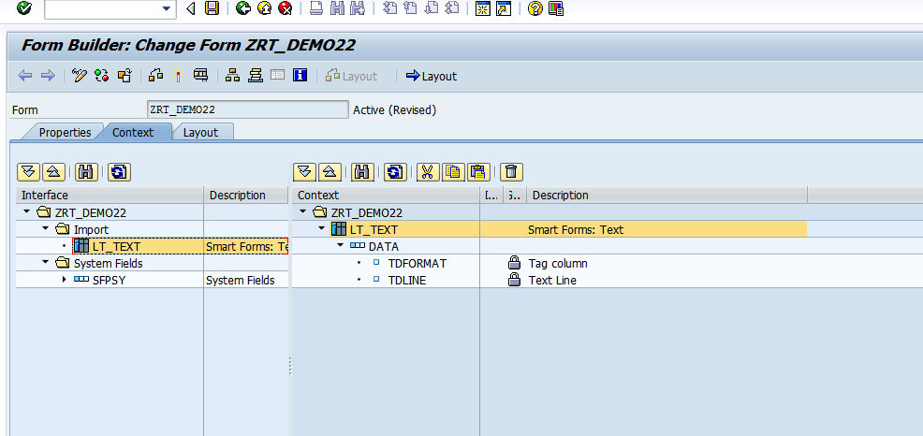

1. **Right click on folder and create text as shown.**

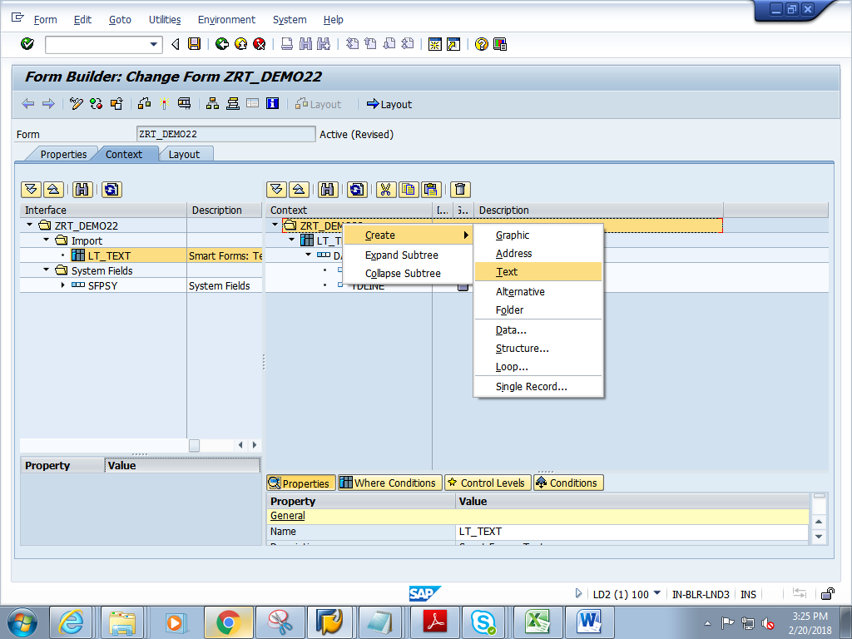

1. **Rename the text to LV_TEXTDYNAMIC**

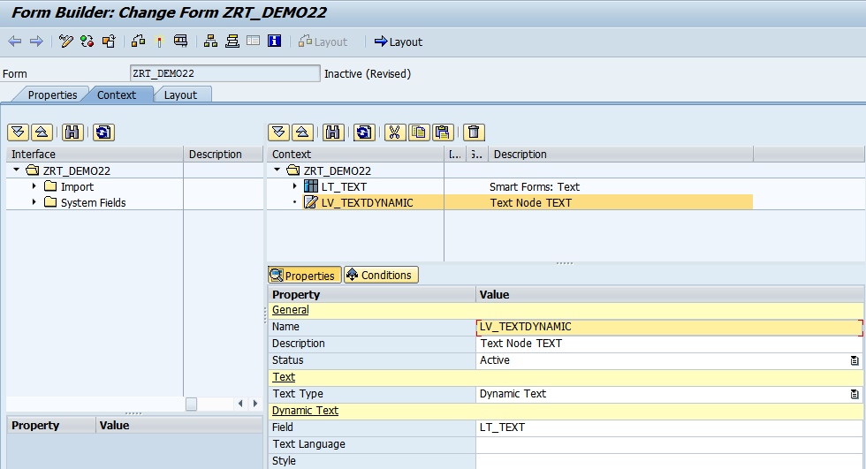

1. **Change Text Type to DYNAMIC TEXT and press enter**

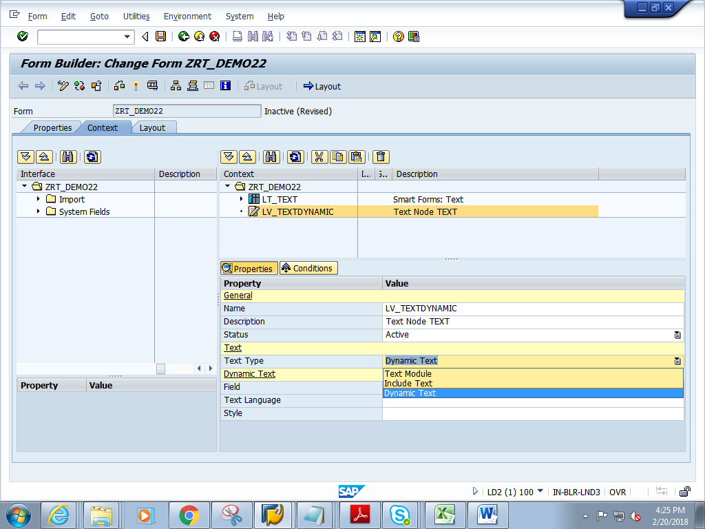

1. **Give the Field as LT_TEXT**

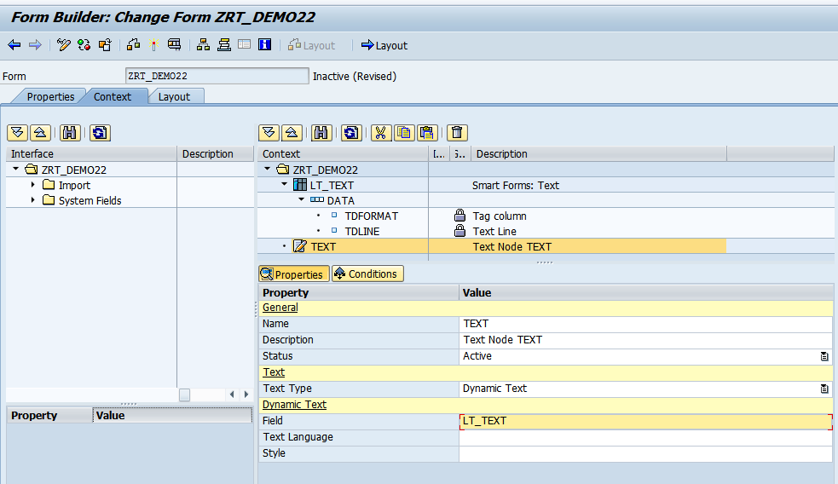

1. **Save and click on Layout**
2. **In the Layout, drag and drop Text from Object Library to Design View. Resize the Text box and make it big enough.**

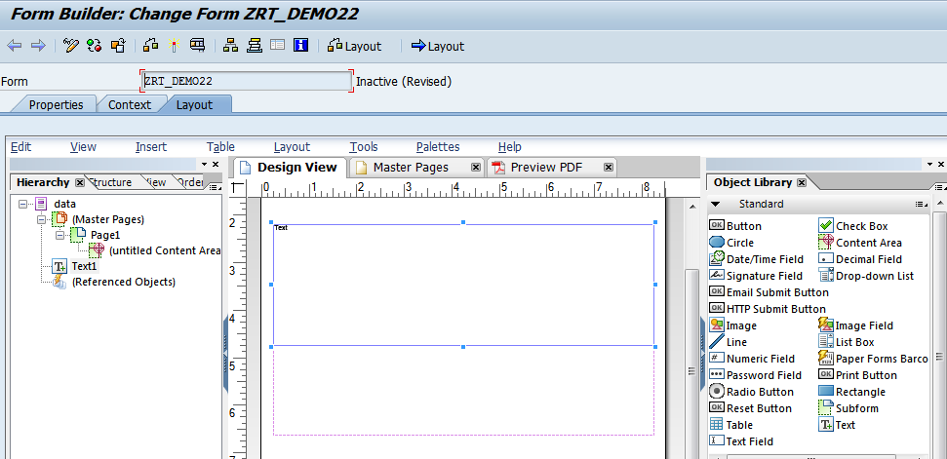

1. **Right click on the word Text in the Text box and choose Floating field option**

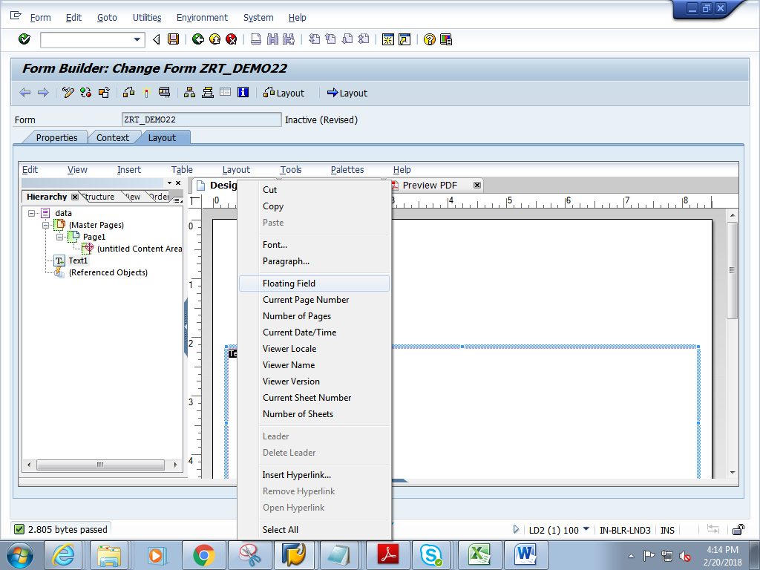

1. **Select the text, then in the object window->Binding tab-> choose LV_TEXTDYNAMIC**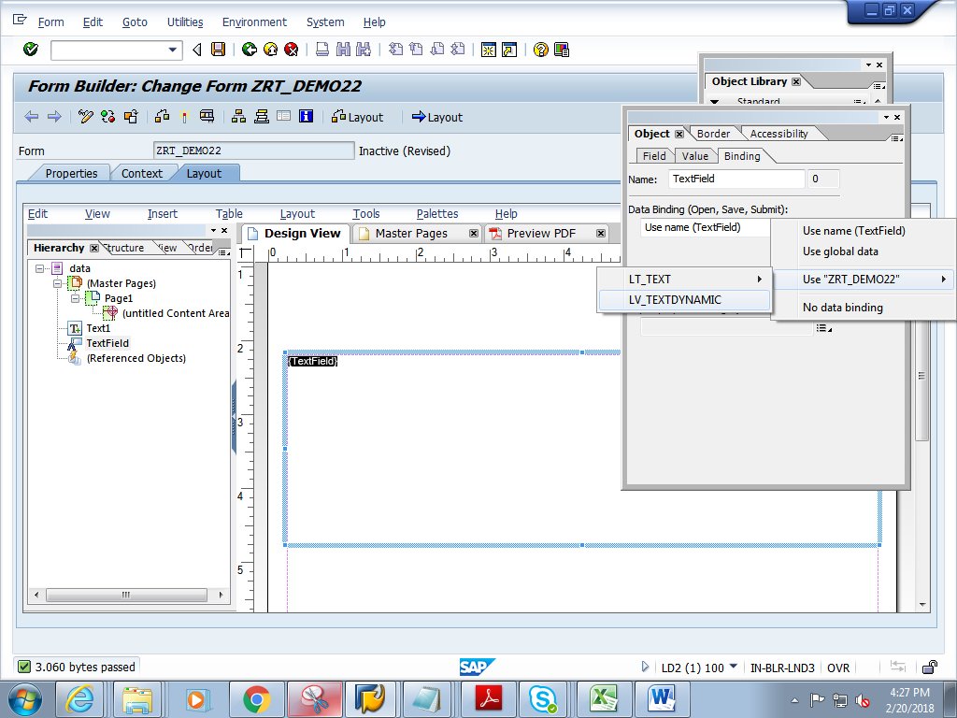
2. **Save and close Layout.**
3. **Click on context. Save and activate the form**
4. **Execute the form .**

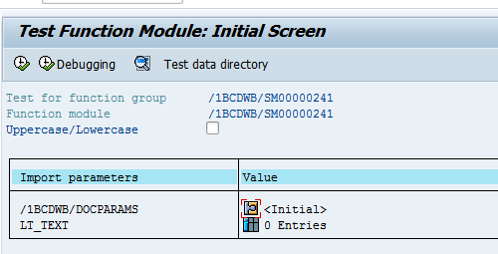

1. **Create some internal table rows and go back.**

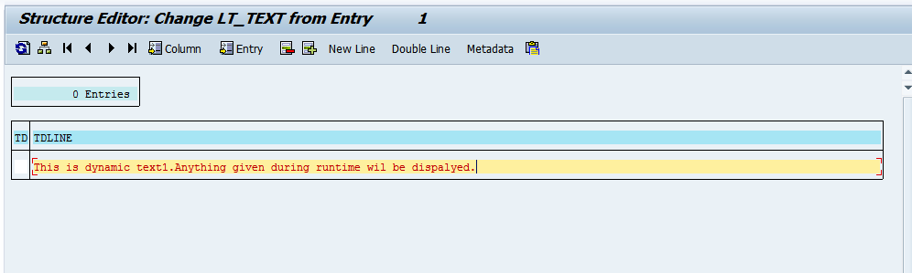

1. **You can see 1 entry in the table. Execute.**

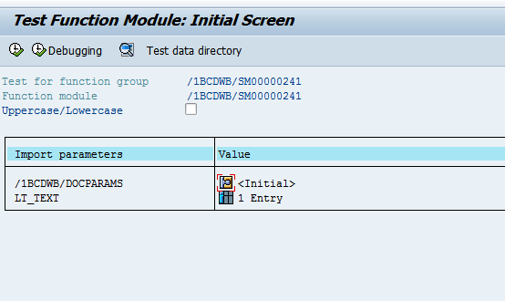

1. **Click on Print preview**
2. **Expected output is as follows.**

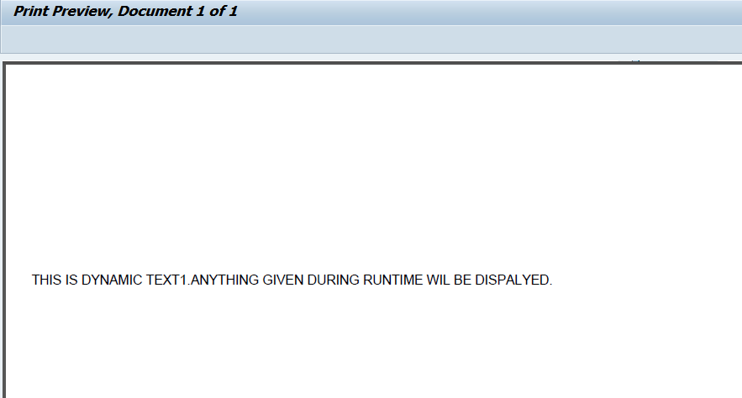

**Q-5. Demonstrate a case to use INCLUDE TEXT in adobe forms.**

1. **Create a Standard text named ZRT in tcode So10 .Add the below line in the text**

**zyny_standard_text**

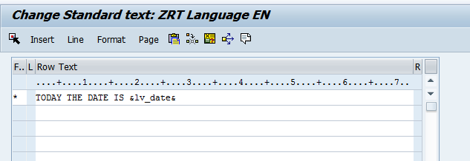

1. **Go to T code SFP. Create an interface and then create a form (For details ,please refer the previous demos)**
2. **In the interface, create a global variable LV_DATE.**

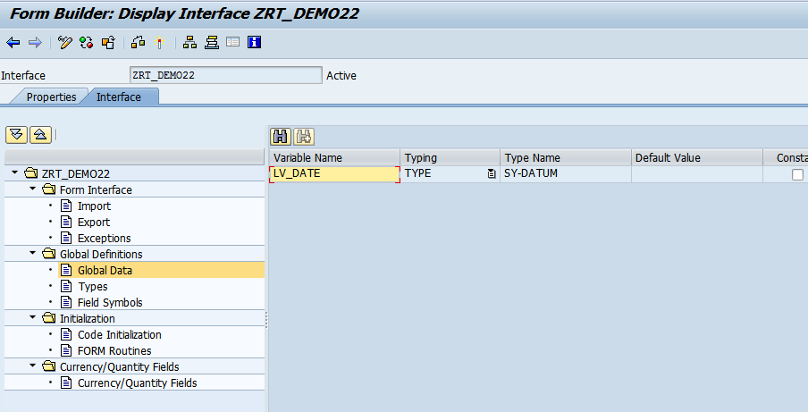

1. **In the Initialisation, write the below code.**

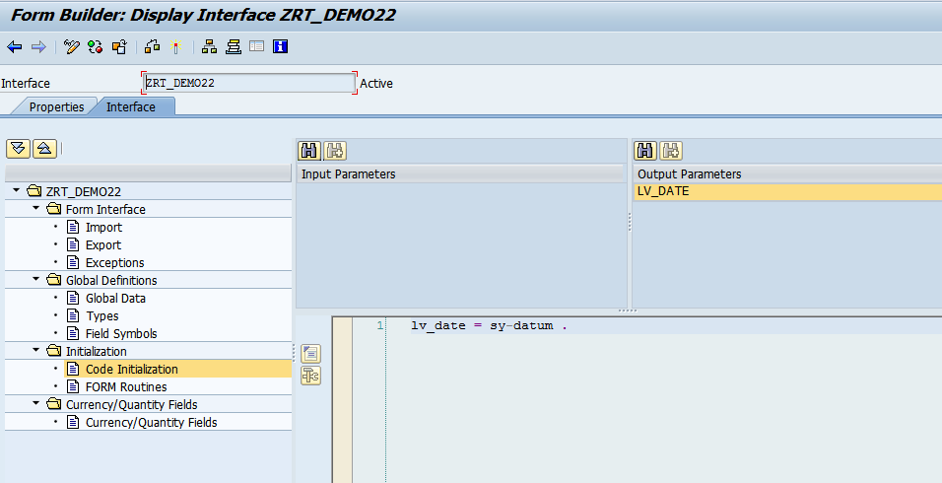

1. **Open the Form. In the context window, create TEXT node as shown below.**

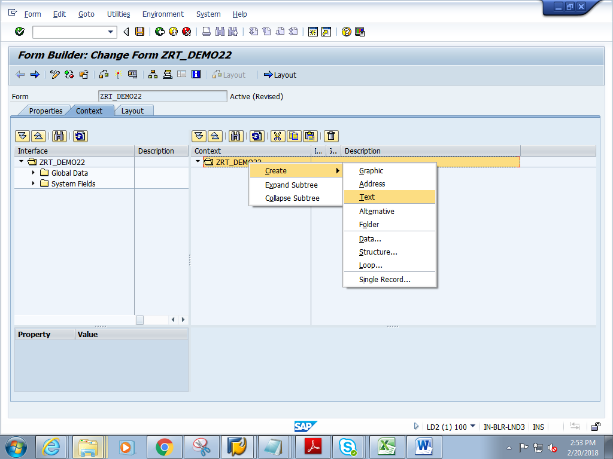

1. **Change Text Type to INCLUDE TEXT and press enter**

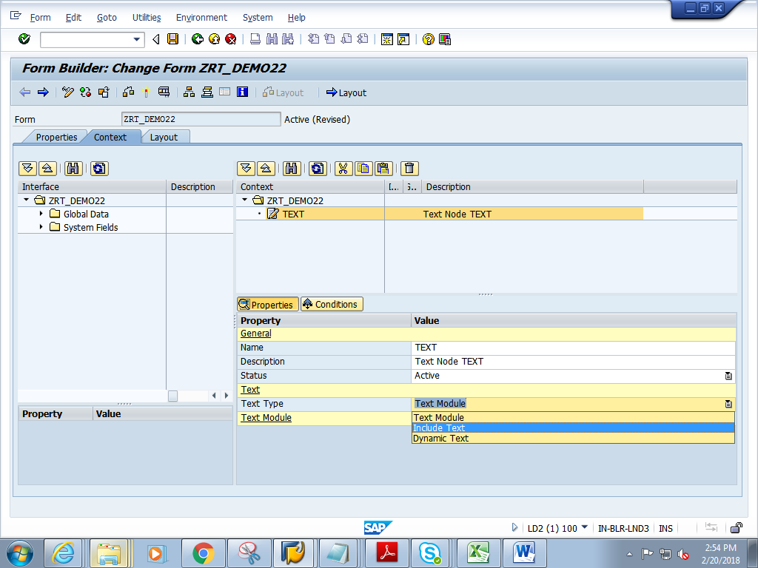

1. **Press f4 on TEXT NAME**

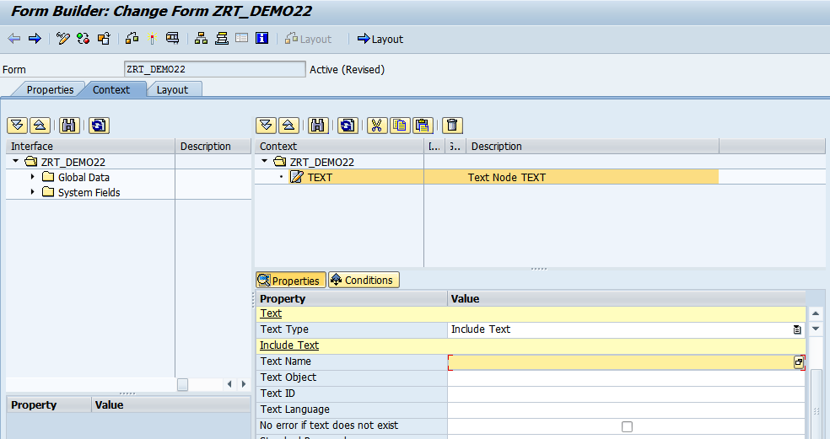

1. **Give the TEXT name as ZRT(created in So10) and click on continue**

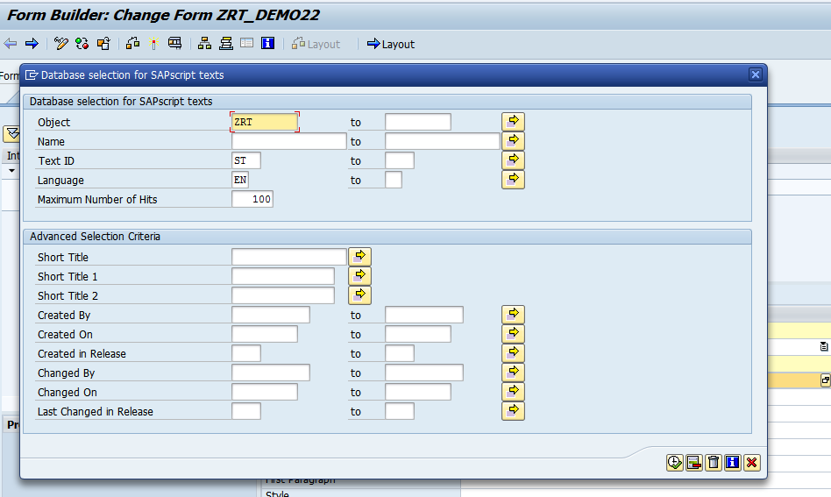

1. **The fields under Include Text get populated**

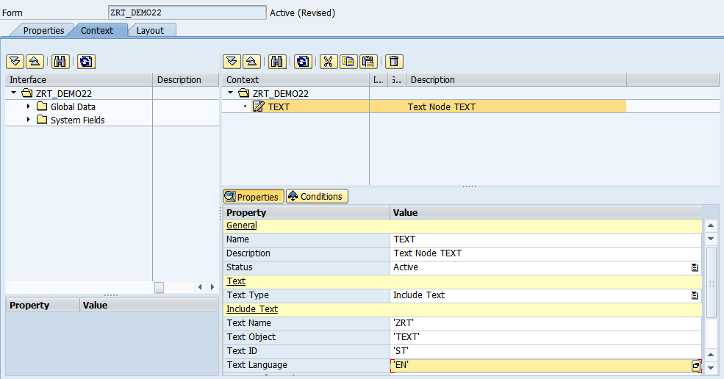

1. **Drag and drop the lv_date from Global Data to Context**

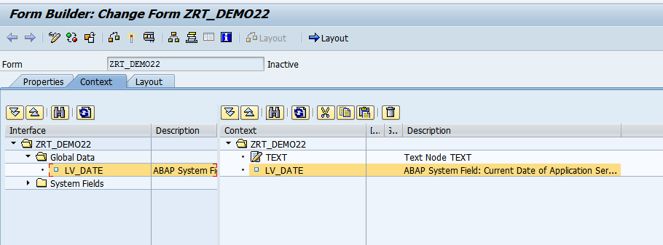

1. **Save and click on Layout**
2. **In the Layout, drag and drop Text from Hierarchy to the Design view.**

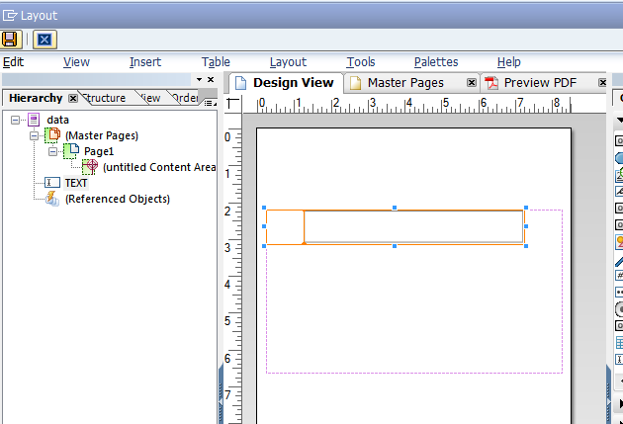

1. **Save and close Layout.**
2. **Click on context. Save and activate the form**
3. **Execute the form .Execute the function module**

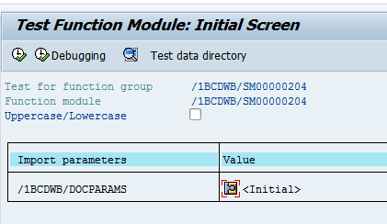

1. **Click on Print preview**
2. **Expected output is as follows.**

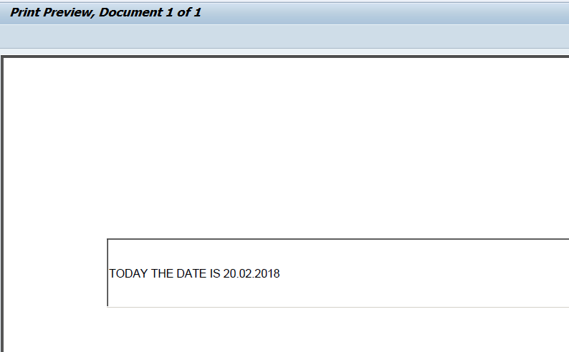

**Q-6. Create a case to use image from SE78 in adobe forms.**

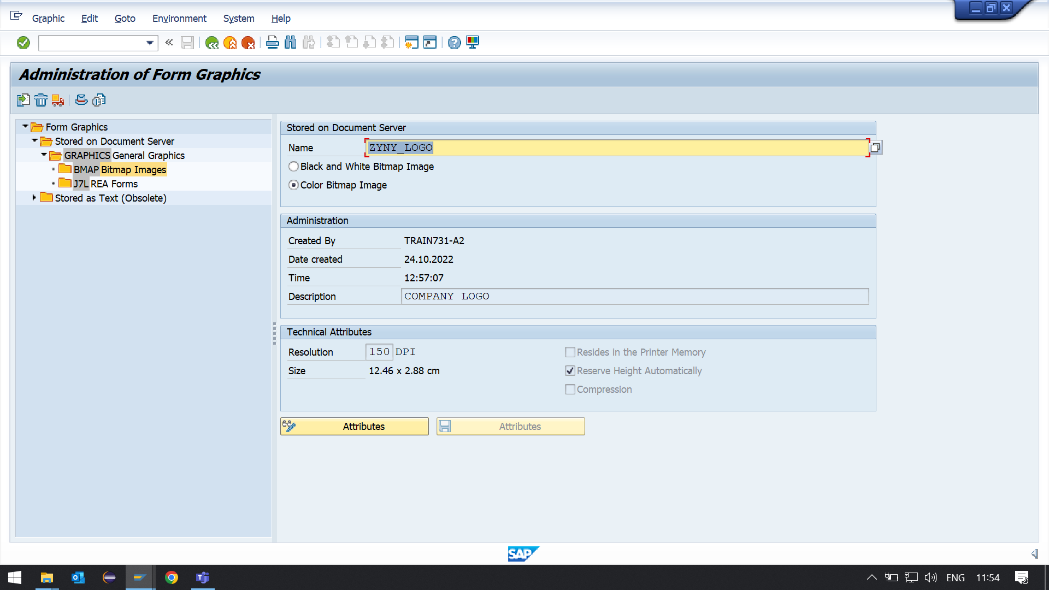

1. **Upload any image from local system through t code SE78.**
2. **Go to T code SFP. Create an interface and then create a form (For details ,please refer the previous demo)**
3. **Open the interface. In the global data add the 2 variables**

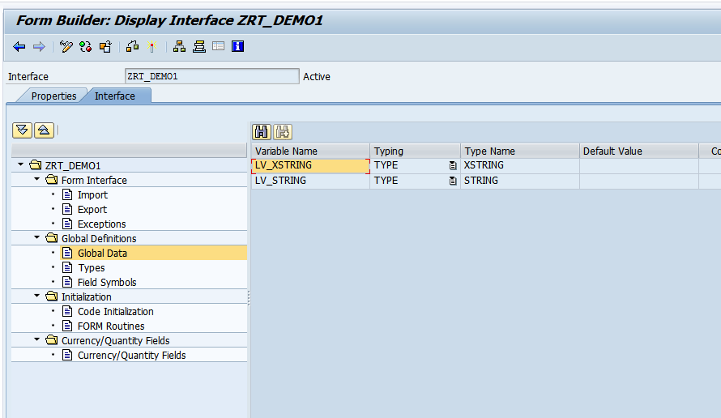

1. **In the intialisation section, add the below code.**

**Note:'SAP_RT' is the name of the image uploaded in SE78**

**Here must check if the image already present**

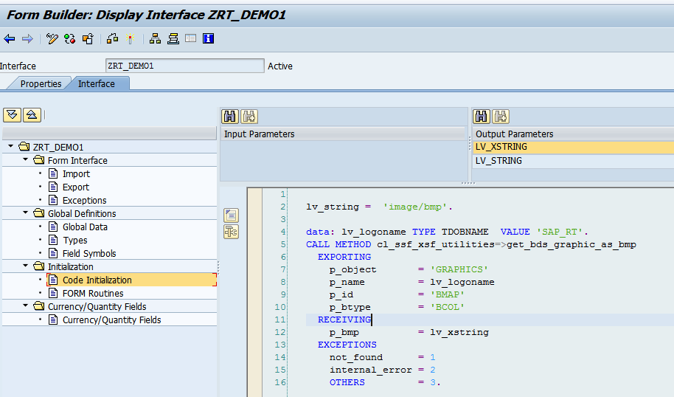

1. **Open the Adobe form. In the context tab, right click on the folder ZRT_DEM01-Create-Graphic**

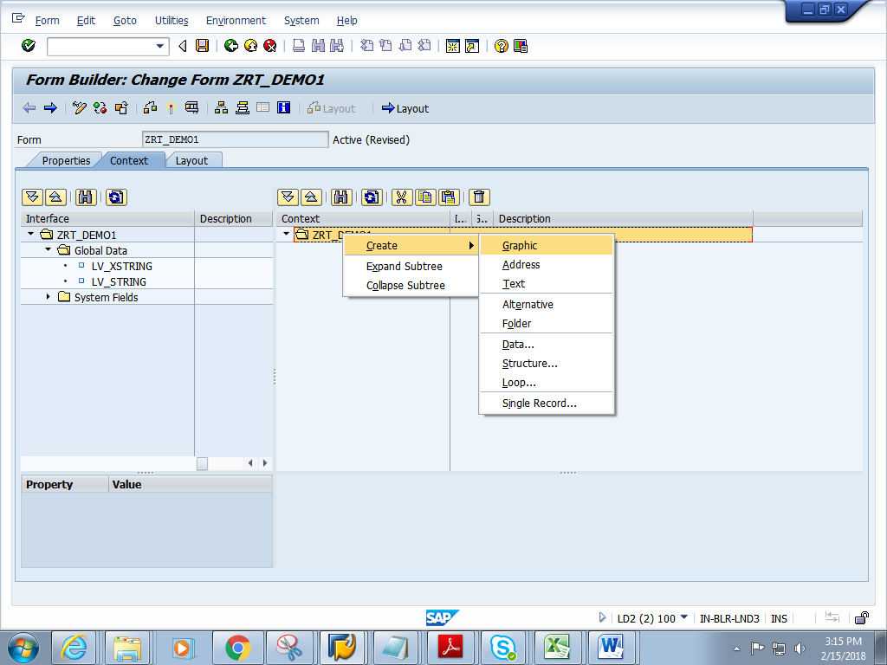

**5) Double click the GRAPHIC. In the properties window, change the Graphic type to GRAPHIC CONTENT**

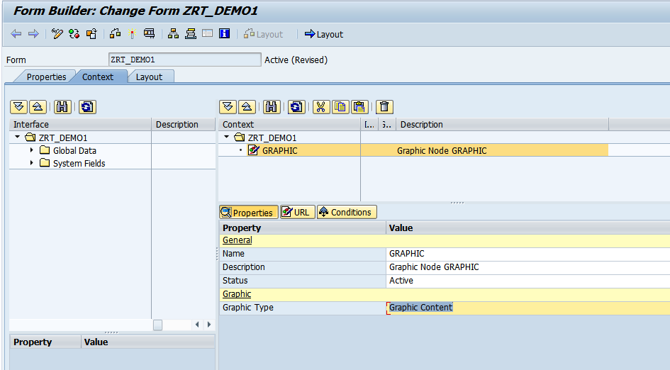

1. **Give the Field and MIME type as shown below.Click on Layout**

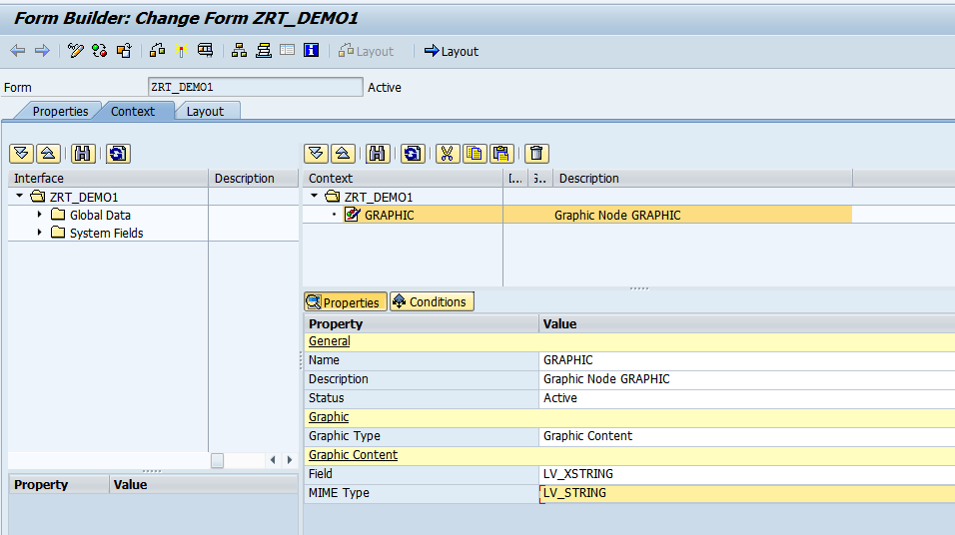

**7) Drag and drop the Image Field to the Design View.**

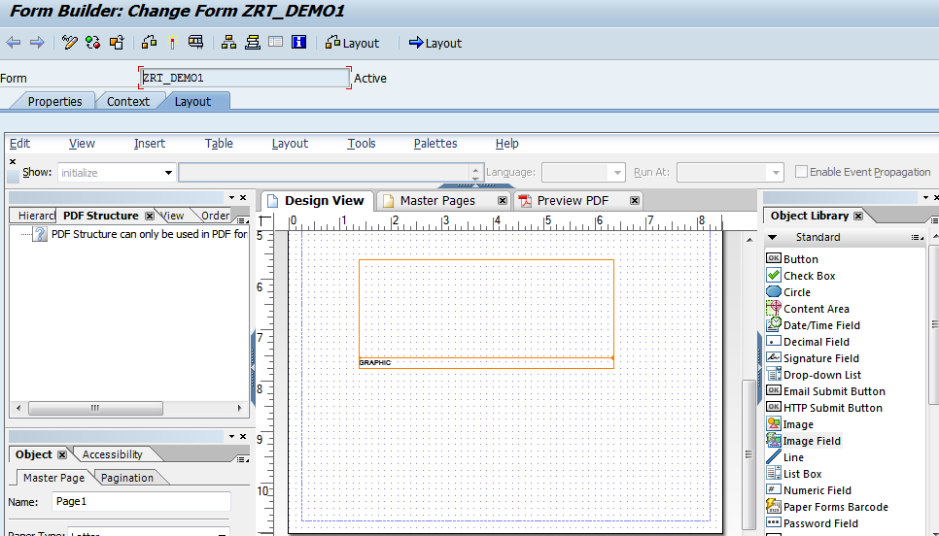

**8) In the object window, Check the embed image data check box.**

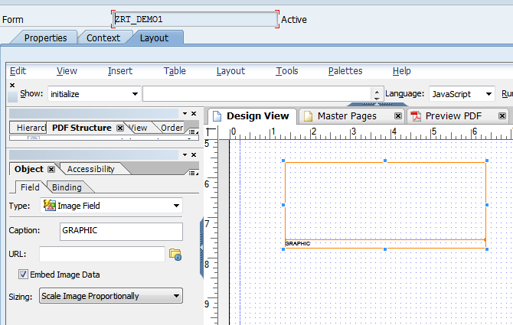

**9) In the binding window, bind the GRAPHIC as shown below**

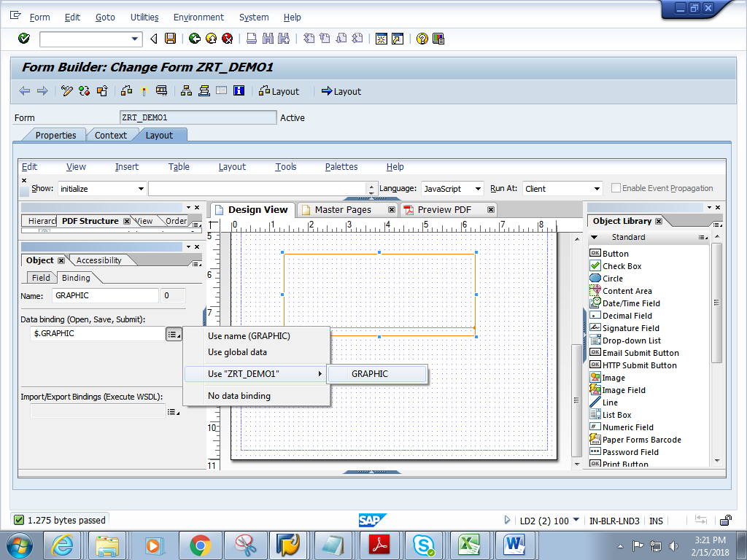

**9) Click on context. Save and activate the form.**

**10) Execute the form .Execute the function module**

**11) Click on Print preview**

**12) Expected output is as follows.**

